Fencers will be selected for International events in Paris and Poland 2018 as follows:

- SELECTION SUMMARY

For 2018 International events, selections will be allocated as follows:

1a U17 Foil – Challenge CEP Marathon, Paris 2018. In 2018, there will be a pilot to introduce an U17 squad to the Challenge CEP Marathon in Paris. The aim of this is to provide a pathway for fencers into Cadet fencing.
- Fencers in each gender finishing in the top 4 of the 2017 EYC U15 foil events with a year of birth 2002 will be automatically selected.
- The remaining places (to a total of 12 per gender and weapon) will be allocated according to the England Fencing weapon specific ranking list. Year of birth 2001 and 2002

1b U15 Epee, sabre and foil- Challenge Wratslavia, Wroclaw Poland:
- Fencers in each gender finishing in the top 4 of the 2017 EYC U15 weapon specific events will be selected automatically. Year of birth 2003 and 2004.
- The remaining places (to a total of 12 per gender and weapon) will be allocated according to the England Fencing U15 weapon specific ranking lists.

(* Fencers must meet the age criteria for 2018 events. This requires the fencer to be over 13 but U15 on January 1st 2018.)

1c For U13 Epee, sabre and foil- Challenge Wratslavia, Wroclaw Poland
- Fencers finishing in the top 4 of the 2017 EYC U13 Year of birth 2005, 2006, 2007
- The remaining places (to a total of 6 per weapon, per gender) will be allocated according to the U13 foil, epee and sabre England ranking lists.
(* Fencers must meet the age criteria for 2018 events, requiring a fencer to be U13 on January 1st 2018.)

- SELECTION DATES
The selection date will normally be 10 days after the final competition in November 2017 and selection will not be subject to any discretion.
Places will be allocated in order of rank, excluding those already qualified via the EYCs. If the date of any foreign event is brought forward significantly and the selection date has to be changed then this fact will be publicised on the England Fencing website and via England Fencing social media.
3) SELECTION EVENTS
The ranking lists shall include the best 5 results from the following competitions in a calendar year from 1st December 2016 to the 31st November 2017:
a) British Youth Championships 2017
b) England Youth Championships 2017 (U13 and U15)
c) British Cadet Championships 2017 (U17)
d) Leon Paul Junior Series competitions in the relevant weapon and age group
that take place from December 2016 to Nov 2017
e) Additional competitions that take place from December 2016 to Nov 2017:
i) for Foil: the Manchester Cadet Tournament, BRC U17 competitions and the
Newham Swords Junior Challenge Series events U12 + U14
ii) for epée: BRC U17 competitions, the Young Hoskyns (U13) and the Elite Epee U12 and U14 Series; Cocks Moor Epee U13 & U15.
iii) for Sabre: BRC U17 competitions and the Stratford U14.

- RANKING SYSTEM
The ranking list co-ordinators will assign points according to a system (See point 8 for calculation of points) to weight the results for both the number of entrants and the relative standard of entrants in any given competition.

- ELIGIBILITY FOR SELECTION

- You must be a British Citizen and hold a UK passport.
- You must also be eligible to represent GBR at international level
- You must be a member of England Fencing

Qualifying fencers must be members of England Fencing Ltd at the time of selection and at the time of the event, must agree (with parental consent) to the code of conduct and conditions (including financial and travel arrangements) of the trip. England Fencing Ltd reserves the right to withhold selection from fencers with an unsatisfactory disciplinary record, or with an outstanding debt to EF or its agents.

In the event that a team manager is unable to contact a selected fencer within a reasonable time-scale, the offer of selection may be withdrawn and offered to the next available fencer from the rankings.

- APPEALS
Any appeal against the accuracy of the final rankings must be made to the ranking keeper within 7 days of the publication of the final rankings. If this does not resolve the issue a further appeal may be made within 10 days of the publication of the final rankings to the Director of Representative Fencing whose decision shall be final.

- AGE CRITERIA
We wish to encourage fencers not to ‘fence up’ into a higher age groups even though some competition organisers allow this discretion.

Ranking points achieved in the selection events will only be allocated to a fencer who fences in their correct age group. Points achieved from older age group categories will be disregarded for the purposes of the England Fencing Ranking system.

Although every effort will be made to provide accurate and timely information, England Fencing Ltd. reserves the right to alter the selection policy without notice.

- HOW POINTS ARE CALCULATED
The points for a competition are calculated by multiplying the NIF x Position multiplier. NIF is a value reflecting the strength of a competition. The position multiplier is a range of values between 1.4 and 20. The higher the fencer is placed, the higher the multiplier.

Note that there are steps in the position multiplier table at 4th/5th, 8th/9th and 16th/17th rewarding the fencer who succeeds in winning more DE fights. The effect of this is that a fencer might earn more points for a 12th place in a strong competition like the BYC U14 than they would by coming 3rd in a relatively weak LPJS.
Weighting the competitions (NIF) takes place because some competitions are harder than others. This is a function of both the quality and the quantity of the opposition. We have borrowed the concept of NIF from adult competitions. The idea is that you look at the list of entrants to a competition and allocate a value to each fencer relative to their overall seasonal performance. In order to do this, one has to have some benchmark of performance which in this case is the EYC and BYC competitions plus, in certain cases, the British Cadet rankings.

We have designated certain fencers to have a youth NIF as follows:

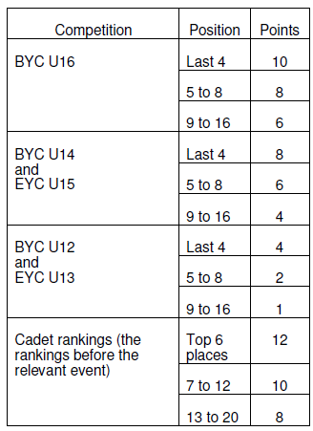

We also add ¼ of a NIF point for every non-NIF fencer attending a competition. Sometimes a fencer qualifies for different NIF values, in which case the higher value is used. For example, the Ashton LPJS Foil 2007 U13 had 18 entrants. Clyde (NIF 8), Davis and Cruise (NIF 4 each), Williams, Lee and Roberts (NIF 2 each) and Selby, Bailey and Collier (NIF 1 each) plus 9 non-NIF fencers at a ¼ point each. Total NIF for that comp was 27.25.At Eton LPJS Foil 2007 U13 however, many more strong fencers competed, as well as 42 non-NIF fencers, so that NIF was 53.5. Cadet rankings (the rankings immediately before the relevant event) should be used ONLY for U17 selection competition

Position Multipliers
The conventional position multipliers that we use at Senior comps are designed to spread over 64
places, and are not ideal for a system that only gives points for a L32, or for comps with only 15 or 20
entries. We have used a different multiplier as follows:

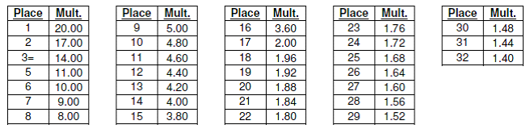
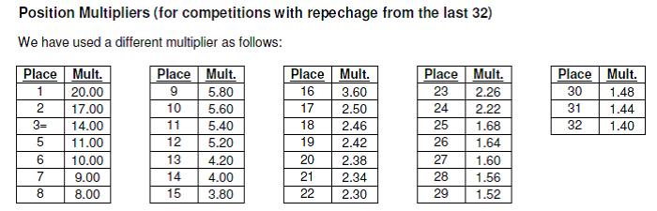
Points are only awarded to fencers finishing in the top 50% of the competition and only if they finishin the L32.

Only the BEST 5 results count for your England Ranking.

NOTES:
i) The main purpose of these trips is to introduce young fencers to the international competition environment and to the atmosphere and requirements of working within a National squad; supporting development towards Great British selection.
ii) Accepting a place on an England Squad may restrict the right of a fencer to represent another country in the future. Individuals who are eligible to represent more than one country should consider these factors before accepting selection.
iii) England Fencing encourages fencers who were close to selection, to make private entries for Paris and Poland and the team managers will do their best to help with practical arrangements. However the standard of these events is extremely high and they are not appropriate for inexperienced competitors.

Link to England Fencing U15 ranking lists: http://englandfencing.co.uk/rankings/

Questions specific to the ranking lists should be directed to the ranking co-ordinators:

Foil – Sandra Beardmore (EnglandRankings@aol.com)

Epee – Rodney Francis (rodneyfrancis@hhl.me.uk)rankings: http://francisfencing.org.uk/wroclaw/

Sabre – Daniel Redshaw (daniel.redshaw@live.co.uk)

For questions about the overall purpose and management of the trips or to volunteer to help, please contact Beth Davidson Director of Representative Fencing E-mail: beth.davidson@englandfencing.org.uk. 07834884194

