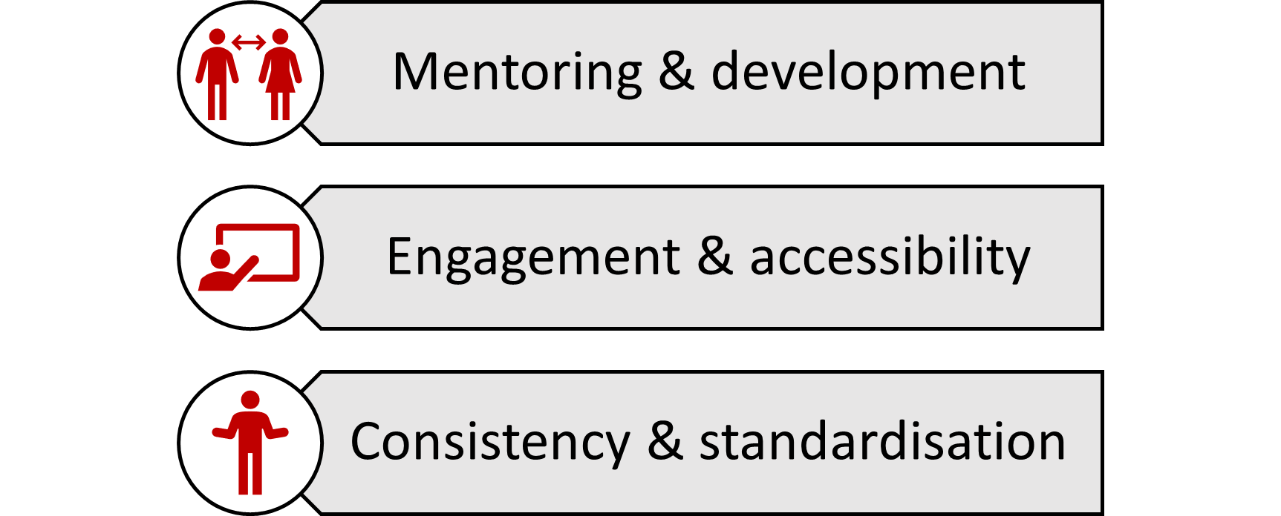
This year’s focus has remained on the three refereeing priorities: mentoring & development; engagements & accessibility; consistency & standardisation. I set out these priorities when I began this role in 2020 and have maintained them through the level 1 & 2 relaunch.

Mentoring & development
This year, after a positive application and selection process, we appointed 7 new combined instructors and mentors, as well as 4 new mentors. Training was run at the British Open Championships, covering an introduction to the referee system, mentoring and safeguarding for referees. A follow-up online call covered these materials for those that weren’t able to make the in-person training. This increase in mentors has led to an increase in practical assessments, as well as a better geographical spread of practical assessments.
In terms of putting this mentoring into practice, the EYC’s provided an opportunity to mentor many of the newer level 2 referees. A mentor was provided for each weapon, to give referees feedback throughout the event. More experienced referees got to do their first finals. Experienced, but unassessed referees, were also given the opportunity to be assessed for their level 2 at the EYCs. Of the 21 candidates, 18 passed their level 2 assessment.
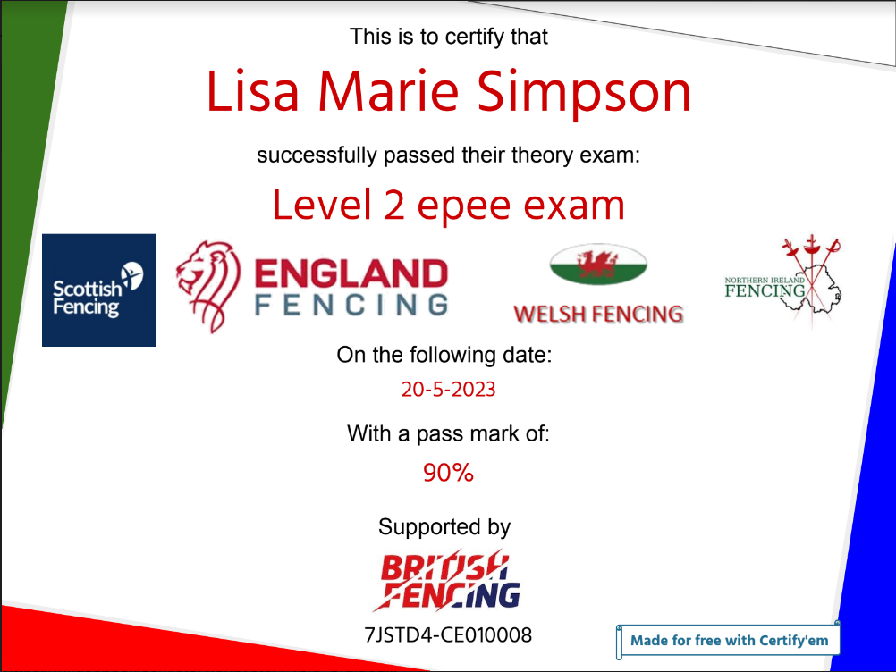
Engagement & accessibility
A big step forward this year was the automation of theory exam certificates when candidates successfully complete the theory course. These new certificates have a unique reference number and are automatically emailed to the candidate. This means they can be used to evidence that candidates have a theory pass when they come to practical assessments.
Automatic scoring and feedback was introduced last year, so candidates can understand the correct answers to the theory questions.
In terms of engagement beyond the exams, 2023 also saw the level 2+ course delivered at multiple events, including the EYCs. This is designed to help referees improve after their initial level 2 training. Further work is still needed to grow these resources and keep them up to date.
Consistency & standardisation
Over 150 referee candidates have attended theory courses and taken exams in 2023. England Fencing also hosted their own first theory courses, with a foil, epee and sabre online courses. These were well attended, with over 25 successful referee candidates. The level 1 courses, aimed at parents and new fencers, are not examined or monitored. However, England Fencing helped organise at least two courses this year.
Following FIE rule changes in January, the level 2 materials were also updated to version 1.8, including P cards rule changes and hit whilst falling guidance. All instructors and mentors received the updated materials, to ensure all new referees get the same theoretical training. The training courses also provided an opportunity to standardise practical assessments.
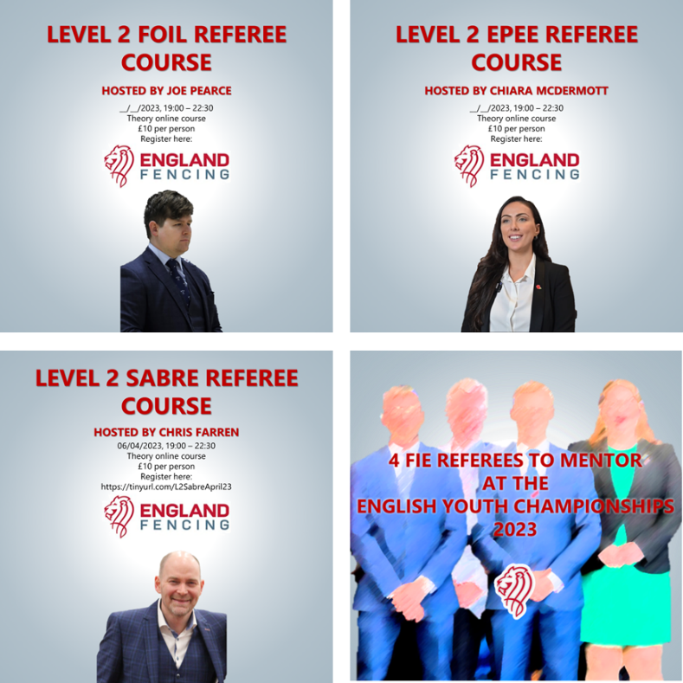
Thank you
Across these three areas, I must thank all the instructors and mentors for delivering the courses, mentoring and materials. A special thanks goes to Nickie Bailey and the British Fencing team for supporting these initiatives, as well as the other home nation referee representatives. Chris Farren deserves special recognition for his wheelchair education programme. And finally, a thank you to Liz Behnke and all her support on safeguarding for referees. If you have questions on any of these topics, or want to host a course, please feel free to reach out to me: luke.deamer@englandfencing.org.uk

